THE
HORMONAL
MAIL
THE OFFICIAL QUARTERLY NEWSLETTER OF CLASSIC LIVESTOCK MANAGEMENT
SERVICES.

VOLUME 1. NO.20.
April 2011

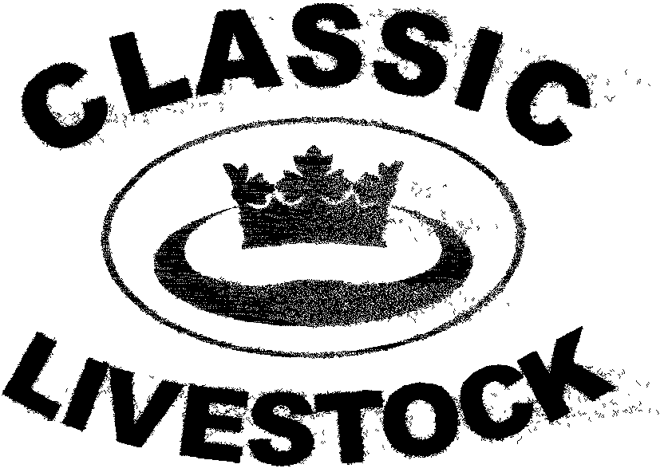

ACN 092435571
P.O. BOX 1181, PHONE: 0741297029/0411201879.
MARYBOROUGH, QLD. 4650.
Email:gewyatt@bigpond.com
Website:www.classiclivestock.com
EDITORIAL.
The unusual seasonal conditions in Eastern Australia over the last 3 - 4 months have certainly presented many challenges to the livestock industry in areas that have been hit hard by floods and cyclonic conditions. The inevitable short term shortage of agricultural products is now being seen in the retail sector and the price of most fresh produce has increased significantly.
This has certainly been the case in regard to beef, with saleyard prices increasing to near record, and in some cases record, levels for most grades and types of cattle. This is caused, not only by the difficulties encountered in getting onto country to muster stock, but also with physically moving stock across wet roads to selling facilities. Unfortunately, there have also been some significant losses of life with stock because of flooding.
In many cases, producers have gone from one extreme of drought to water logging in a few short months and this has meant many are understocked. With the largest feedstocks many producers have experienced for several years becoming available over the next few months, many producers are faced with a dilemma as to how to best utilise it. With the high cost of restocking, there is little likelihood of many producers being able to really capitalise fully on their excess feed. Those buying breeding stock may be a little better positioned as they will be able to spread the initial cost over the breeding life of the animal they purchase. However, they still need to find the initial capital outlay to purchase.
Again, this season highlights the degree that we are controlled by nature with our enterprises and despite the best efforts of science there are some things it can’t control or regulate.

WHAT’S ON.
* On Friday May the 13th. the Coodardie Brahman stud will be holding their annual stud sale at Mataranka. If you are interested in improving the eating quality of your Brahmans then the cattle on offer at this sale will be able to do this. They will have all been graded for meat and milk quality using the CLMS system and their grades will be available. It is also plan to have a taste test of meat from various grades of CLMS graded cattle there for visitors to sample.
*We are currently grading cattle that will be processed in the next couple of months with a view of obtaining some more fat samples to send off for testing for omega 3 levels. The aim is to have another 30 samples tested to bring the total done in the last 9 months up to 50 and this should give us a good indication as to the relationship between animals grading high on the CLMS grading system and those that have above average levels of Omega 3.
*We are also doing some more work on being able to objectively grade cattle (and other cloven hoofed animals as well) for meat quality to support our current methods of evaluation using electronic technology. The aim is to add this to other objective measurements we use such as linear measurement. With the improvement in electronic identification methods and the use of computer software, we feel we need to continue to explore these technological advances as they become available to support what we believe to be true from a practical and observational perspective.

*******************************************************
ENVIRONMENT/GENETICS BALANCE
We have regularly emphasised the importance of balance and consistency as being the over all keys to producing quality products from our livestock and particularly cattle. This is coupled with our holistic approach to the overall production of livestock.
One of our main concerns with much of the current research is that it usually looks at isolated parts of the whole system. Whilst it is often very difficult to do otherwise with a lot of research, there is a need for researchers to acknowledge this in their results and whilst they will rarely be able to see the full impact of their research on other parts of the “system”, it is important that they maintain a realistic view towards the fact that changes in other parts of the system will impact on the results they have obtained in their particular part of that system.
In our research, we have aimed at taking a holistic approach and whilst this has meant that there is less detail in some specific areas of our work, we feel it provides a comprehensive overall view of the situation to the extent that the information provided will take breeders/producers to a very high standard in terms of producing quality. Certainly, from a broad and holistic perspective, we believe that our system provides an unequalled method of evaluation.
In terms of producing quality products from our cattle, we have been able to identify many individual traits that together produce the type of animal that produces quality products.
On a broader basis, we believe that we can identify the key quality areas in cattle and what influences them the most in terms of genetic and environmental factors. The main areas for quality indication that we have considered are meat tenderness, meat palatability, milk quantity, milk quality and fat quality.
Of these, we believe that fat quality is influenced more by what an animal eats than any of the other key areas. Things like the omega 3 and 6 content and the levels of saturated and poly unsaturated fats is influenced more by what the animals are fed than any of the other key indicators. We do believe that all of these areas are genetically influenced as well, but that fat quality is least influenced by genetics. Milk quantity is also influenced by how much and the quality of the feed that cows are fed. However, they need to have a significant genetic potential to be high milk producers to start with. Meat palatability is next most influenced by environmental factors such as feed and seasonal conditions. Diet plays an important part in an animal’s overall hormonal activity and this in turn influences the palatability of the meat. Milk quality is also influenced in a similar way. The area that we believe is least influenced by the environment and therefore the most genetically influenced is that of meat tenderness.
One of our aims in coming years is to be able to more accurately identify the proportion of genetic to environmental influence is prevalent in each area. We would not expect though, to get an exact figure either way for all animals. There could well be up to a 10% variation, if not more, especially in the areas where the environment plays a larger part.
It is our current view, given the work that we have done to date, that genetics will affect around 80% of the end product in all cases. Whilst we have only just started doing fat trials and the results in our first sample didn’t give a lot of clear indicators, one of the most important things we are looking at are the levels of Omega 3 in the fat of animals that we grade as being tender using our system. In the recent small trial, over 80% of the cattle that we graded as tender were also above the average for Omega 3.
Our plan is to continue researching, looking and learning so that we can pass on our findings to the industry at this time when it needs more direction and motivation.

*******************************************************
INTEREST IN SUSTAINABLE AGRICULTURE
I find it interesting that over the last 5 – 6 months I have had contact with, or have become aware of several international companies that are investing or planning to invest in sustainable, natural, agricultural practices.
As far as our company are concerned, we are very supportive of these companies taking this interest. However, it also begs questions about the reasons these companies are taking this interest. Of course, they are doing it as an investment and to make money and that is fair enough. Fair enough, if they are genuinely committed to the long term development of naturally sustainable agricultural systems. The key is, of course, commitment. That commitment has to go much deeper than just the incentive that financial returns may offer. They need to know that by practicing such methods, especially in the early days, they will meet a lot of very powerful opposition.
Firstly, from the chemical industry who rely so heavily on current agricultural practices for the majority of their income, secondly from some parts of the scientific community who have vested interests in research based on the use of chemicals and genetic manipulation of plants and animals and thirdly from those producers who support the use of chemicals on their properties.
Certainly, sustainable, organic agriculture is much more widely publicised now in a positive way compared to 25 – 30 years ago when we first started practicing it and it is becoming more widely acceptable. I know what it is like to be ostracised by neighbours and ridiculed by chemical company representatives.
So these sustainable, natural investing companies will need to be unrelenting in their commitment and then the rewards will flow. One of their major challenges will be to find managers and workers who share their commitment. As well intentioned as they may be in their goals, if they don’t have the right people managing their investments, then they won’t work.
One of the companies I am aware of is buying properties and then in an arrangement with the previous owner, appointing them as the manager. I know of one such case where the previous owner, now manager, is still using a considerable amount of chemical that the owners are not aware of. I’ve always believed that it is a bad move to appoint the previous owner of a business to a management role in the new business. Usually the previous owner has sold the business because they can’t make a sustainable profit from it or that they have lost the incentive to work the property/business to its highest degree of efficiency and are therefore not committed enough.
Another of these companies is considering taking a different approach where the current owners maintain the property, but take advice, financial support where required and guidance from the investing company. This concept has a far greater chance of success because of the commitment and heavier vested interest of the owners.
These companies obviously see organic, sustainable and natural agriculture as one of the more attractive areas of investment that is likely to give them high returns, thus their interest. They are also attracted by the government incentives for introducing carbon and energy saving and sustainable technology into industry.
8. SOLITARY REFINEMENT
I just thought I would share some thoughts about the loneliness and aloneness that many primary producers so often experience on a daily basis. It is often just the nature of our business that we find ourselves alone whether it be sitting in a tractor, on a horse or doing any of the multitude of roles that are part of a farming enterprise that are one man or woman jobs.
Let’s explore some of the ways that we can approach this fairly common aspect of farming. It is about exploring ourselves, because many of us don’t give this topic much, if any, conscious thought. We either fear what we might find in the inner depths of our minds or make excuses for not going there. It can end up becoming a dis-ease within us if we don’t acknowledge it, sometimes accept it or at least be consciously aware of it. As such, that is, a dis-ease within us, it can manifest itself in many ways including as a physical ailment, tiredness, stress, confusion, frustration or ultimately a life threatening disease or condition.
We don’t necessarily have to do anything about it if it is not something that causes us any concern and is not affecting our daily life or performance as a manager or business owner. In fact, the solitude we experience at these times can provide us with just the time we need to plan future business developments or give thought to personal and family issues.
It is when this loneliness becomes something that we don’t believe anyone else understands, when we find excuses that don’t exist for any little incident that occurs and when blame takes every ounce of energy from within us. This is energy that we can’t afford to lose in a non productive way and we lose sight of how to keep and use it as the foundation for positive changes to the way we perceive our world.
It is not uncommon for our thoughts to wander into places of negativity when we are alone for long periods of time on a regular basis. The most difficult thing to be able to do is actually develop an awareness that you are in such a place and that it is not doing anything for your well being. To develop this awareness is not easy, but not impossible either. In a sense when you are in such a situation, you are actually in a self imposed trance and the way to change your state into another focus or level is to develop some triggers that will over ride that trance state.
To do this you need to be aware of the instant you came out of that state and become aware of how you were feeling during that state and what physical things were happening within your body including your head. Were there any unusual pains, twitches, stiffness, etc. as you went into the state?
Become aware of these and consciously note them as anchors so that when ever you become aware of them again you know that you are going into a state of thinking that will not be positive for you. It is often also helpful to have another anchor such as a deep breath or breaths as you become aware that you were about to go somewhere you didn’t need to go and just use that as a quick time out to re focus. It is important that you also have some preconceived topics and thoughts that are more positive to be able to go to as soon as you are aware of the negative thoughts starting. If you are going to get rid of or replace anything negative or non productive in your mind then you need something to replace it with or those thoughts will just return.
If it is not a place where you want to be then what are the alternatives?
If it is a current problem that you have in your business that is causing stress and anxiety, then there are a couple of options. One is to remember a time when you had a similar situation or it might be that you have to take a broader approach if you haven’t had a similar experience and look at a way you successfully solved any problem in the past. It may be a solution to a very simple thing that could work now for a more complex issue. The most important thing is to give it a chance to work. You know something similar has already worked so there is a very good chance of success again with the current problem.
Another option is to use a problem solving process that allows you to examine all the relevant factors around the problem and with the use of good questions you can work out progressively some good options to solve the current problem. This is a more objective approach. One process that would be worth trying is the one we shared with you at the end of Newsletter No. 15 in January 2010. You can look it up on our website if you don’t have a copy under past newsletters.
This process can be adapted to fit a range of issues as well as your values.
Hopefully this will assist when some the darker sides of loneliness start to invade your thoughts in the future.
*******************************************************
BREED OF THE QUARTER
NADUDANA.
Nineteen miniature Zebu cattle were first bought to Australia in 1995 and renamed Nadudana, which means “small cattle” in the Hindi language.
Miniature Zebu differs from other small cattle in that they are a natural breed. They are not just bred to be smaller each generation or aren’t just the results of a breeding-gone-bad. This breed is actually one of the oldest known cattle breeds, dating back to 6000 BC. They are believed to have originated in Southern India or Sri Lanka. Their height is between 90 and 107 cm. tall measured just behind the hump. They have similar characteristics to their larger zebu cousins such as the Brahman, especially in regard to their hump, a characteristic of most Bos Indicus breeds.
Some of the other characteristics promoted by breeders are that this breed has a long life span, living 20 plus years with good care. We currently own one of the original bulls that came to Australia and he would be at least 18 years old now and still producing calves. They are intelligent and resistant to flies due to their very active sub-dermal (under the skin) twitching muscles. They have functional sweat glands that aid in cooling which makes them more heat tolerant. They may be accepted in a variety of colours including, grey, near-white, spotted, black or red.
Our company first became involved with the Nadudana’s about 8 – 9 years ago when we evaluated a small herd between Bungendore and Braidwood in NSW. at Mullon Station. What was impressive with this herd was that well over 60% of the herd graded as 3 or better for tenderness. This is the highest percentage of top grades that we have seen in any herd on the first evaluation.
Since then we have had contact with a number of other breeders of Nadudana’s, mainly in Queensland and can see them increasing in popularity as a breed, especially on small properties. They are ideal cattle in tropical climates to replace other small breeds such as Dexters and Lowlines that are popular in cooler climates.
*******************************************************
NEVER CHEAT ON A COUNTRY WOMAN!
A country wife came home just in time to find her husband in bed with another woman. With super-human strength, borne of fury, and cutting firewood, lifting sacks of feed, and bales of hay, she dragged him down the stairs, out the back door, and into the barn.
She put his manhood in a vice and then secured it tightly and removed the handle. Next she picked up an old carpenter's saw.
The banged-up-cheater was terrified and hollered, ! "Stop! Stop! You're not gonna cut it off with that rusty saw, are you?"
The wife, with a gleam of revenge in her eye, put the saw in her husband's hand and said ......
"Nope....You are!
I'm gonna burn down the Barn!"
******************************************************
Thank you for your continued interest in our newsletters, our website and our book. Please feel free to order one of our books and become familiar with the CLMS system and the directions we are taking in the overall scheme of animal and food production for human consumption
PLEASE FEEL FREE TO CONTACT US ABOUT ANY ITEMS IN THIS NEWSLETTER, ON OUR WEBSITE OR IN OUR NEW MANUAL. WE WELCOME PRODUCER INPUT AND INTEREST AND WANT TO INVOLVE YOU IN WHAT WE ARE DOING.
Disclaimer: - Information contained in this newsletter is believed to be true and accurate at the time of publication. Classic Livestock Management Services is not liable to any person or organisation, whether in negligence or other wise for anything published or omitted from this publication.

